Educator Licensure and Renewal Portal
District User Guide

District Search Features 2
Starting, Submitting, and Expediting a District Waiver Application 2
Creating and Submitting an Educator Review 8

District Search Features
There are several district search options to look up educators in ELAR. First, you may search for educators by clicking the District tab on the top navigation and then clicking on Person Search under the Search section. You may search by the educator’s MEPID, last four of their SSN, their Date of Birth, or by their License Number.

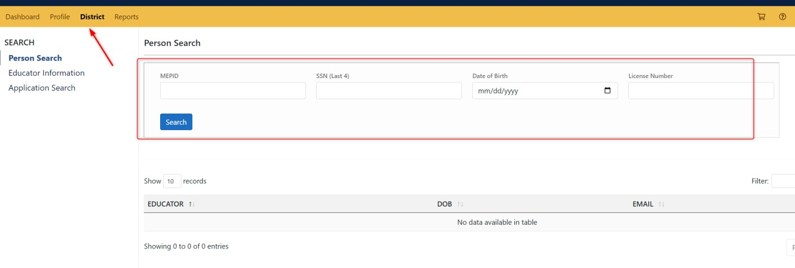

In addition to the general person search, you may conduct a bulk search for Educator Information for multiple educators at once to get a list of the licensure statuses and active applications for all educators searched. Click on the Educator Information, where there will be a search field to enter Educator MEPIDs. You may enter multiple MEPIDs at once separated by commas, and then you may click on the Search button. The results will display below the search field.
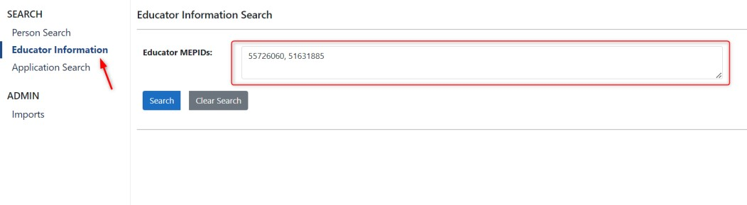

Starting, Submitting, and Expediting a District Waiver Application
Once you are logged into your account, you will need to search for the educator for whom would like to start a district waiver application. You may search for educators by clicking the District tab on the top navigation and then clicking on Person Search under the Search section. You may search by the educator’s MEPID, last four of their SSN, their Date of Birth, or by their License Number.

Once you find the educator, click on their name, and then you will be taken to their profile. Once you are in their profile, you will then need to click on the Applications link in the left-hand navigation menu. Note: to start a district waiver for an educator, the educator must have already submitted a licensure application for the specific type of license you are requesting the waiver for.
After you have clicked on the Applications link, you will then need to start a new application by clicking on the +New button at the top of the Applications page.

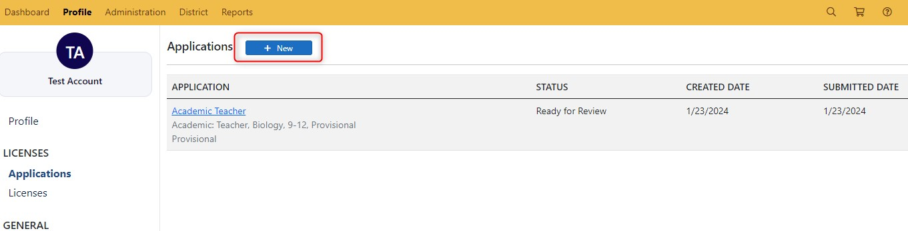

Once you have clicked on the +New button, you will then have a dropdown menu to choose the license that you would like to request a waiver for and the district. The only credential(s) that will appear in the dropdown menu is the one(s) for which the educator has already applied. Select the credential an district in the dropdown menus, and then click the Next button.
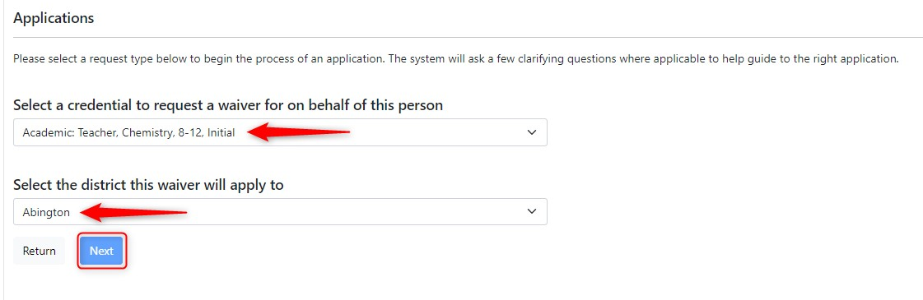

Clicking the next button will immediately create the District Waiver application, and you will be taken to the overview screen of the application. Within the overview screen, you will see any licenses the educator holds, and all applications open for the educator. To complete the Waiver application, you will need to click on the specific Elements of the application either on the left-side navigation under Elements, or in the middle section of the screen under the Requirements section of the application.
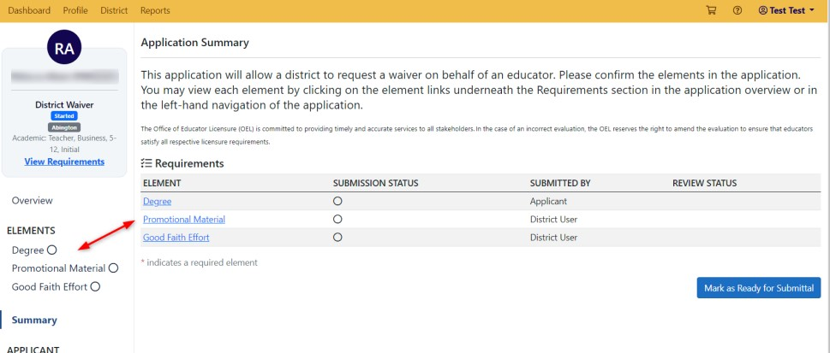

To add attachment(s) to an element, click on the Choose File button under the Attachments section of the element. After you have uploaded a document, you may then click the +Add button, which will attach the document to the element. You may add multiple documents to a single element, and you may add attachments to elements even after you have confirmed the element, but not after the application has already been submitted and is Ready for Review.
Some elements may also require a PIN signature. Make sure you check the confirmation box for elements before clicking Save & Continue. You must insert the PIN for the user (click on the Forgot your PIN link next to the Sign button to see the user’s PIN), and then click Sign before you will be able to confirm the element. Once the element is confirmed, you may click Save & Continue and move to the next element (if applicable).
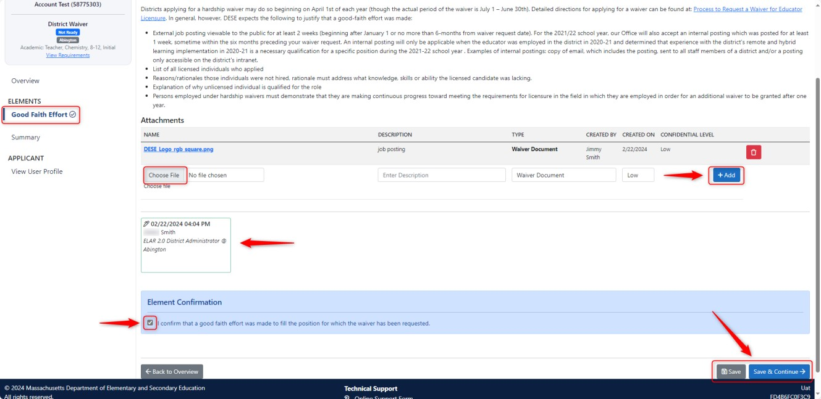

Each element will have a green check next to it if that element is confirmed (or signed and confirmed). Once all elements are ready for submission, you may go to the Application Summary. You will automatically go to the summary after clicking Save & Continue on the last element of the application, or by clicking the Summary link in the left-hand navigation of the application.
In the application Summary, click the button that says, Mark as Ready for Submittal.
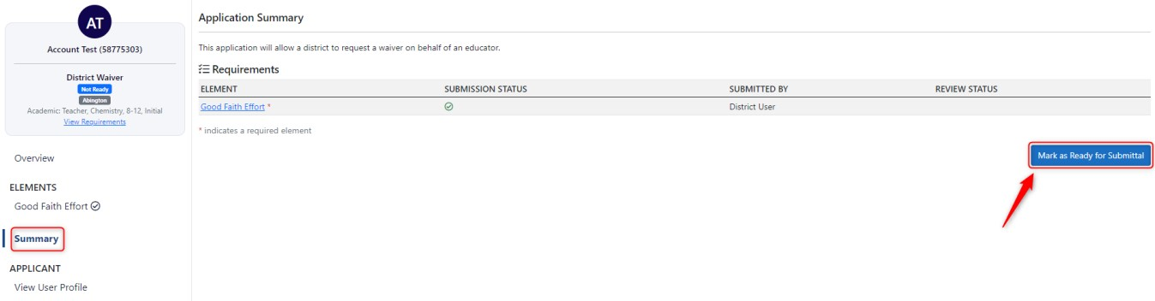

Once you have marked the District Waiver application as ready for submittal, you will be taken to the submission page. Click the box next to the District Waiver application, and then click on Proceed to Submit. This will submit the application for review.
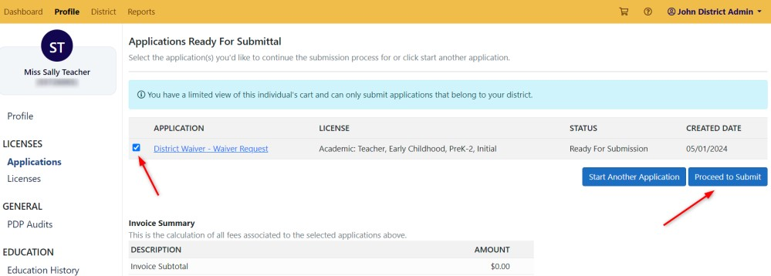

As a District Admin user, after an application is submitted, you may also flag the application to be expedited. Go back to the submitted application, and then click on the Overview link for the application. When you are in the overview of the Submitted application, you may click on the button Expedite Application. Clicking this will flag the application to be expedited.
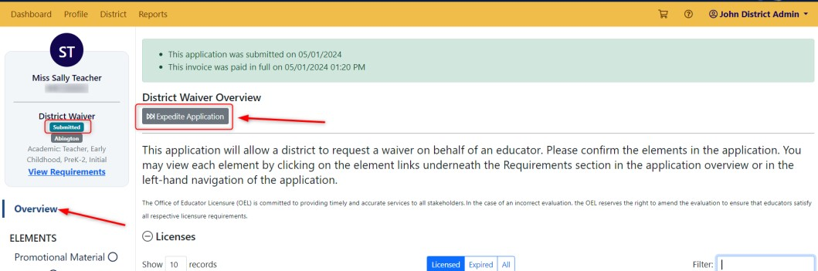

Note: The expedited flag will remain regardless of changes in status to the application, such as Pending, or if the application is resubmitted if more information is needed. The only way to unexpedite the application is to click the button again.

Creating and Submitting an Educator Review
An educator review is a direct way within ELAR for districts to report and document allegations of educator misconduct to the Office of Professional Practices Investigations. Educator reviews may be created manually by a District Administrator. When an educator review is created, the educator is essentially considered “under review.”
A new review may be manually created for an educator by going to the educator’s profile, clicking on Reviews, and then clicking on the +New button.
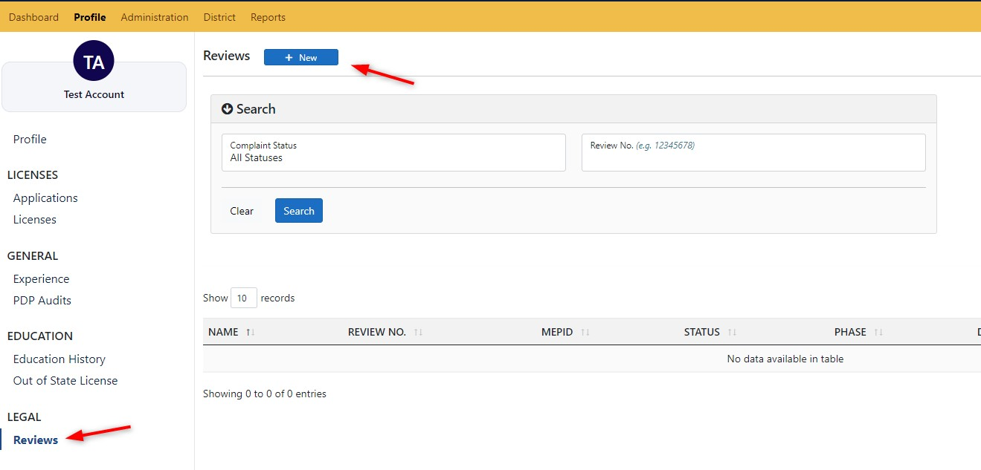

Reviews have several sections, including the educator’s Demographic Information, Reviewee
Information, comments, supporting documents, and Investigation Information, if needed. As a District Administrator, the Reviewee Information has the most fields to complete regarding the reasoning behind the review. Select the appropriate options from the dropdown menu.
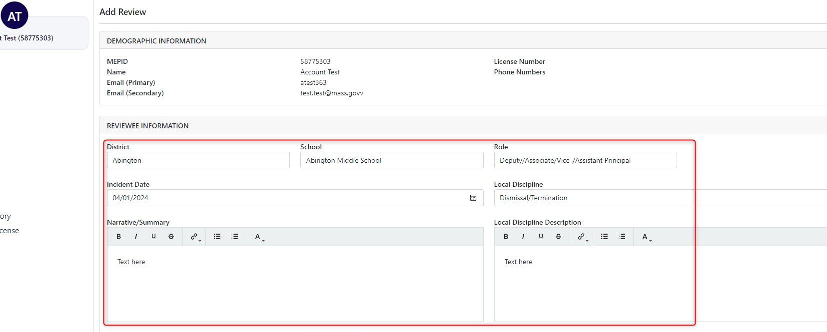

If you would like to save your work on the review but are not ready to submit it, simply click the Save button at the bottom of the review page, which will save your progress at any time. Once you are ready to submit the review, you must sign using your PIN, then click on Save & Submit. The option to save and submit will only be available after the review is PIN/signed. Keep in mind that before submitting a review to OPPI within ELAR, the Commissioner's Office must first be notified of the allegations against the educator.
Once a review is manually created and then saved and submitted, OPPI Legal staff will assess the review.
Note: if the review was created in error, then you may also click on the Delete button at the bottom of the review page before the review is submitted.
